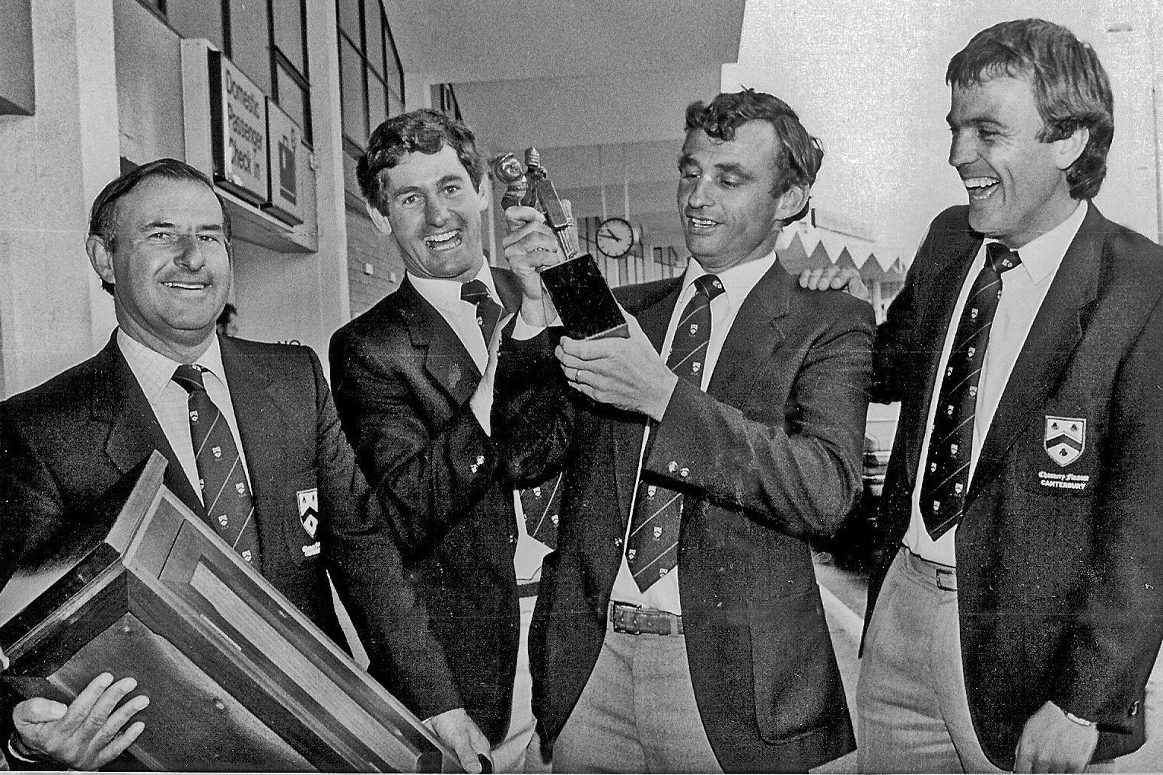

Canterbury team members arrive at Christchurch Airport with the Shell Trophy 12 March 1984

**From left:** BC Adams (manager), PE McEwan, CL Bull (captain), VR Brown